References / Annotated Bibliography about the extent and damage wrought by the Exxon Valdez Oil Spill on fish communities.

(Peterson et al. 2003)

Science summary of information about exxon 15 years later. Provides a few detailed example of detailed studies on physiology

*Cascades of indirect effects.* Indirect effects can be as important as direct trophic interactions in structuring communities (*35*). Cascading indirect effects are delayed in operation because they are mediated through changes in an intermediary. Perhaps the two generally most influential types of indirect interactions are (i) trophic cascades in which predators reduce abundance of their prey, which in turn releases the prey’s food species from control (*36*); and (ii) provision of biogenic habitat by organisms that serve as or create important physical structure in the environment (*37* ).

Expectations of rapid recovery based on short generation times of most intertidal plants and animals are naïve and must be replaced by a generalized concept of how interspecific in- teractions will lead to a sequence of delayed indirect effects over a decade or longer (*7*).

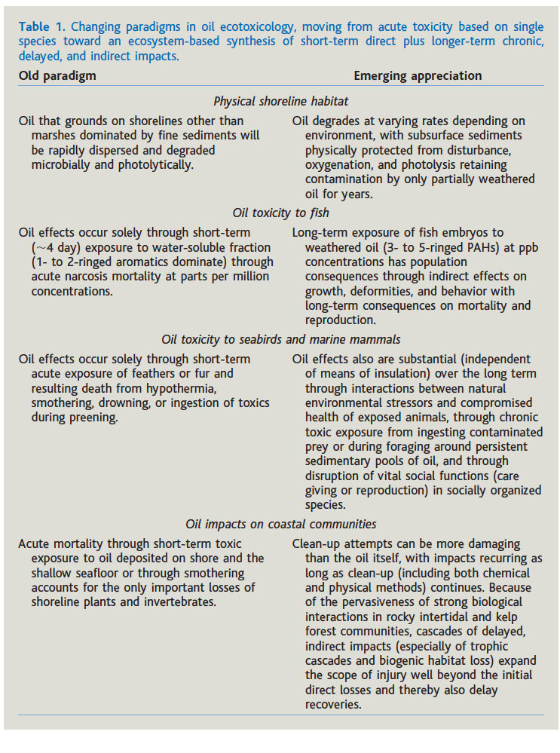

(Sol et al. 2000)

This paper talks about increased exposure to oil near the spill site in three fish (yellowfin sole, dolly varden, Pollock) and how reproductive parameters decline with more exposure. These are physiological indicators of exposure. Also, there appeared to be a geographic cline in insults to the fish (fish down shelikof strait had less problems). This was true even though samples were take 1 or 2 years after the oil spill (90 or 91) suggesting that oil effects can be persistent.

(Collier et al. 1993)

Abstract

“*Our results show a continuing exposure of several fish species, including benthic species, which indicates petroleum contamination of subtidal areas. We have also assessed reproductive function and histopathological alterations in sev- eral of these species; and while major effects have not been documented, some suggestion of histopathological alterations of gill exists in one species of benthic fish. Still to be determined are the potential impacts on fishery resources of long-term exposure to petroleum, albeit at moderate to low levels.*”

(Jewett et al. 2002)

masked greenling

Abstract ”In 1999, fishes collected from sites adjacent to intertidal mussel beds containing lingering Exxon Valdez oil had elevated endothelial CYP1A and EROD, and high concentrations of biliary FACs. Fishes from sites near unoiled mussel beds, but within the original spill trajectory, also showed evidence of hydrocarbon exposure, although there were no correlations between sediment petroleum hydrocarbon and any of the biomarkers. Our data show that 10 years after the spill, nearshore fishes within the original spill zone were still exposed to residual EVOS hydrocarbons.”

(Page et al. 1996, 1999)

These seem to be from some guy paid by Exxon. They don’t really make a lot of sense but seem to be arguing for natural oil seeps as the source of subtidal oil.

(WOLFE et al. 1994)

description of where the oil that was spilled ended up. Plenty of evidence that it reached deep water.

Although the mass transport from beaches to shallow subtidal sediments was not quantified, the amount (Figure 2) was estimated, along with shoreline dispersion and

(Paine et al. 1996)

The lightest most toxic fraction probably evaporated within the first 10 days and constituted more than 20% of the total amount(172). Degradation of heavier oil fraction takes a great deal longer and is often assumed to follow an exponential decline, as hydrocarbons are broken down by light and by microbial consumers(172). Five years after the spill, about 2% of the oil remained onbeaches and 13% in sediments with onlya tiny fraction still dispersed in water(172)

# 172 is Wolfe et al. 1994.

(Short & Heintz 1997)

Some empirical modeling of the dispersal of oil

(Short et al. 2007)

There is still oil on the beaches in Alaska from Exxon.

Fish were exposed, even slight exposure can have physiological and fitness effects

(Collier et al. 1993, Hicken et al. 2011, Incardona et al. 2012, 2015)

Rockfish were exposed to oil (Marty et al. 2003)

(Feder & Blanchard 1998)

This paper does the space comparison between oiled and unoiled spots . Doesn’t find much but then it didn’t have a very good statistical design

(Hicken et al. 2011)

PNAS paper about sublethal effects of oil on experimental zebra fish populations.

Thought on Anderson et al. In book (Armstrong et al. 1995)

A lot of these analyses and conclusions stem from the assumption that lethal levels of oil or derivatives need to be present in the water column to cause harm. E.g. “On a population level, the extent of the negative effect is excess of deined toxic thresholds, is dispersed relatibe to the distribution of the population and the length of time such toxic levels persist. Ecologically toxic concentrations of water-soluble fractions (WSF) used in modeling impact scenarios for several Alaskan oil and gas pre-lease sales are generally set at a lower limit of 0.01 ppm, considered toxic to eggs and larvae of temperate water species, although adult stages may be 10- to 20- fold less sensitive.

Also tends to frame in whole-population terms: “only a small area of total population in gulf would be affected”

No acute effects…

Ole’s summary:

Most useful aspects of the Armstrong et al. paper is that they document oil getting to deep water and in the water column.

Direct evidence: oil showed up in trawls.

Animal evidence: This evidence is from scallops (high in 1989, decline relatively quickly), mussels (high in 1989, decline pretty quickly), Infaunal bivalves had evidence of some petrogenic sources through 1991 though this is somewhat spatially variable. Suggestion that local non-spill sources oil PAHs and the like may be unavailable biologically. Flathead sole had evidence of bile metabolites associated with the spill but it looks like sole are getting the exposure through their diet.

Look up Cabioch et al. 1978 Amoco Cadiz for a reference to 3d dispersal of oil.

Paywall.

Laevastu and Fukuhara 1985 [ pain in the ass grey literature report]

“Oil on the bottom of the sea – a simulation study of oil sedimentation and its effects on the Bristol Bay ecosystem” Final report No. 36 Part 1 (1986) U.S. Department of Commerce, NOAA/ OCSEAP pp. 395-454.

Clark, B.R. 1992. Marine Pollution. 3rd ed Clarendon Press. Oxford, England 172 pp.

(Gundlach et al. 1983) Where oil ended up in France after a big spill.

Santa Barbara spill Squirre 1992

(Squire 1992) Pelagic species spatial distirubtion relative to oil spill.

Other spills:

Manen and Pelto 1984

Linden et al. 1979

(Krahn et al. 1992). Demonstrates exposure to oil in pollock and salmon using a mix of experimental and field collections.

(Peterson 2001)

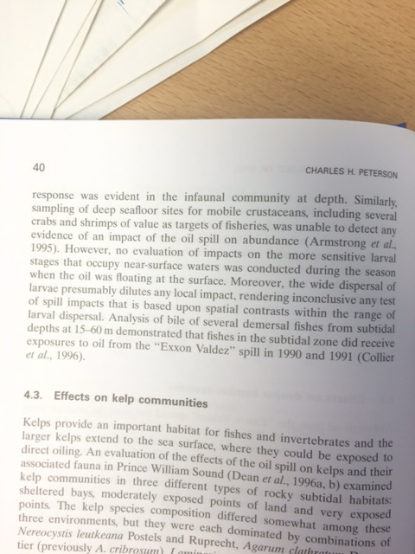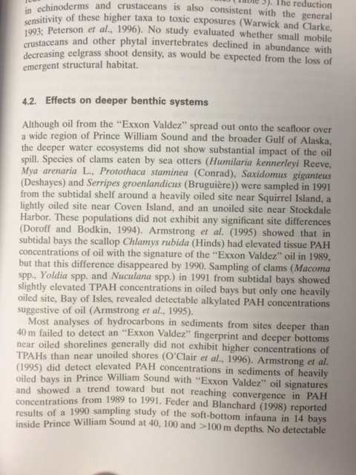

Armstrong DA, Dinnel PA, Orensanz JM, Armstrong JL, McDonald TL, Cusimano RF, Nemeth RS, Landolt ML, Skalski JR, Lee RF, Huggett RJ (1995) Status of selected bottomfish and crustacean species in Prince William Sound Following the. In: Wells PG, Butler JN, Hughes JS (eds) Exxon Valdez Oil Spill: Fate and Effects in Alaskan Waters. ASTM International, 100 Barr Harbor Drive, PO Box C700, West Conshohocken, PA 19428-2959, p 485–547

Collier TK, Krahn MM, Krone CA, Johnson LL, Myers MS, Chan S-L, Varanasi U (1993) OIL EXPOSURE AND EFFECTS IN SUBTIDAL FISH FOLLOWING THE EXXON VALDEZ OIL SPILL. http://dxdoiorg/107901/2169-3358-1993-1-301

Feder HM, Blanchard A (1998) The deep benthos of Prince William Sound, Alaska, 16 months after the Exxon Valdez oil spill. MARINE POLLUTION BULLETIN 36:118–130

Gundlach ER, Boehm PD, Marchand M, Atlas RM, Ward DM, WOLFE DA (1983) The Fate of Amoco Cadiz Oil. Science 221:122–129

Hicken CE, Linbo TL, Baldwin DH, Willis ML, Myers MS, Holland L, Larsen M, Stekoll MS, Rice SD, Collier TK, Scholz NL, Incardona JP (2011) Sublethal exposure to crude oil during embryonic development alters cardiac morphology and reduces aerobic capacity in adult fish. Proceedings of the National Academy of Sciences 108:7086–7090

Incardona JP, Carls MG, Holland L, Linbo TL, Baldwin DH, Myers MS, Peck KA, Tagal M, Rice SD, Scholz NL (2015) Very low embryonic crude oil exposures cause lasting cardiac defects in salmon and herring. Scientific Reports 5

Incardona JP, Vines CA, Anulacion BF, Baldwin DH, Day HL, French BL, Labenia JS, Linbo TL, Myers MS, Olson OP, Sloan CA, Sol S, Griffin FJ, Menard K, Morgan SG, West JE, Collier TK, Ylitalo GM, Cherr GN, Scholz NL (2012) Unexpectedly high mortality in Pacific herring embryos exposed to the 2007 Cosco Busan oil spill in San Francisco Bay. Proceedings of the National Academy of Sciences 109:E51–E58

Jewett SC, Dean TA, Woodin BR, Hoberg MK, Stegeman JJ (2002) Exposure to hydrocarbons 10 years after the Exxon Valdez oil spill: evidence from cytochrome P4501A expression and biliary FACs in nearshore demersal fishes. Marine Environmental Research 54:21–48

Krahn MM, Burrows DG, Ylitalo GM, Brown DW, Wigren CA, Collier TK, Chan S-L, Varanasi U (1992) Mass spectrometric analysis for aromatic compounds in bile of fish sampled after the Exxon Valdez oil spill. Environmental … 26:116–126

Marty GD, Hoffmann A, Okihiro MS, Hepler K, Hanes D (2003) Retrospective analysis: bile hydrocarbons and histopathology of demersal rockfish in Prince William Sound, Alaska, after the Exxon Valdez oil spill. Marine Environmental Research 56:569–584

Page DS, Boehm PD, Douglas GS, Bence AE, Burns WA, Mankiewicz PJ (1996) The natural petroleum hydrocarbon background in subtidal sediments of prince william sound, Alaska, USA. Environ Toxicol Chem 15:1266–1281

Page DS, Boehm PD, Douglas GS, Bence AE, Burns WA, Mankiewicz PJ (1999) Pyrogenic Polycyclic Aromatic Hydrocarbons in Sediments Record Past Human Activity: A Case Study in Prince William Sound, Alaska. MARINE POLLUTION BULLETIN 38:247–260

Paine RT, Ruesink JL, Sun A, Soulanille EL (1996) Trouble on Oiled Waters: Lessons from the Exxon Valdez Oil Spill on JSTOR. Annual Review of …

Peterson C, Rice S, Short J, Esler D, Bodkin J, Ballachey B, Irons D (2003) Long-term ecosystem response to the Exxon Valdez oil spill. Science 302:2082–2086

Peterson CH (2001) The “Exxon Valdez” oil spill in Alaska: Acute, indirect and chronic effects on the ecosystem. In: Elsevier, p 1–103

Short JW, Heintz RA (1997) Identification of Exxon Valdez Oil in Sediments and Tissues from Prince William Sound and the Northwestern Gulf of Alaska Based on a PAH Weathering Model. Environ Sci Technol

Short JW, Irvine GV, Mann DH, Maselko JM, Pella JJ, Lindeberg MR, Payne JR, Driskell WB, Rice SD (2007) Slightly Weathered Exxon ValdezOil Persists in Gulf of Alaska Beach Sediments after 16 Years. Environ Sci Technol 41:1245–1250

Sol SY, Johnson LL, Horness BH, Collier TK (2000) Relationship Between Oil Exposure and Reproductive Parameters in Fish Collected Following the Exxon Valdez Oil Spill. MARINE POLLUTION BULLETIN 40:1139–1147

Squire JL Jr (1992) Effects of the Santa Barbara, Calif., Oil Spill on the Apparent Abundance of Pelagic Fishery Resources. Marine Fisheries Review 54:7–14

WOLFE DA, HAMEEDI MJ, GALT JA, WATABAYASHI G, SHORT J, O'CLAIRE C, RICE S, MICHEL J, PAYNE JR, BRADDOCK J, HANNA S, SALE D (1994) The Fate of the Oil Spilled from the Exxon Valdez. Environmental Science and Technology 28:560A–568A